**UI name:** Start Page (UI)



**Figure x Start Page (UI x)**

**Description**: The start page shows the online map automatic and buttons for user to switching map.

• Online map

• Offline map

**UI name:** Show Online map (UI x)

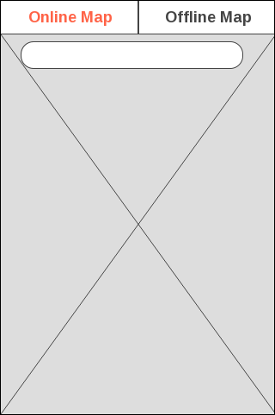

**Figure x Show Online map (UI x)**

**Description**: The switcher tab online button shows the online map for automatic on Start page. The online map will provide search bar to user search help place on the online map. The button allows users to access the online map.

**UI name:** Show Offline map (UI x)



**Figure x Show Offline map (UI x)**

**Description**: The switcher tab offline button shows the offline map for Start page. The button allows users to access the offline map.

**UI name:** Show Offline map (UI x)



**Figure x Show Offline map (UI x)**

**Description**: The switcher tab offline button shows the offline map. The button allows users to access the offline map.

**UI name:** MapsWithMe application (UI x)

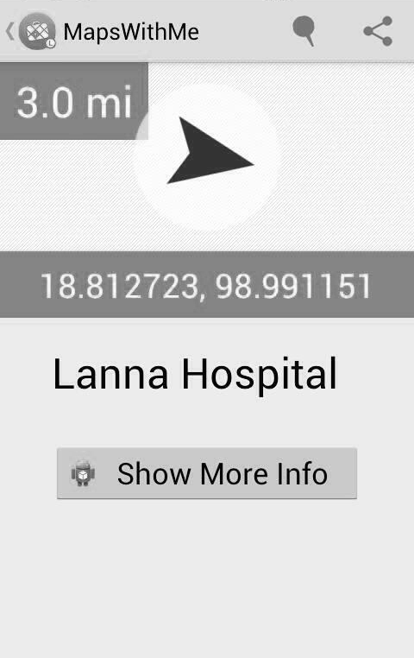

**Figure x MapsWithMe application (UI x)**

**Description**: MapsWithMe application will start with show offline map. The user selects the help place on offline map to view information. MapsWithMe provides latitude, longitude, name and show more info button.

**UI name:** Show Information Page (UI x)

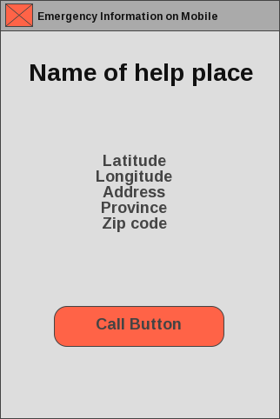

**Figure x Show Information Page (UI x)**

**Description**: The Show Information page will show latitude, longitude, address, province, zip code and call button. On show information page, the user can call to help place directly from the application.

**UI name:** Setting Page (UI x)

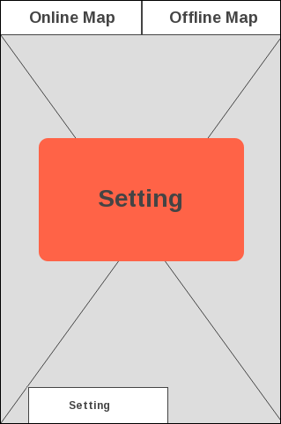

**Figure x Setting Page (UI x)**

**Description**: The Setting Page will show menu for setting the working condition of application. The button allows users to access the setting button on navigation bar android.